CHURCHES IN THE DEEPEST SOUTHWEST OF WORCESTERSHIRE
This route starts in the attractive riverside town of Upton upon Severn and goes west and south of the town through countryside at the south end of the Malvern hills. All the churches are on O.S. Map 150. You can stop at any point or miss a church
As most people now have either a sat nav or google maps on their phone, I have added the post code of each church and omitted instructions for moving between them.
UPTON BAPTIST CHAPEL WR8 0HN
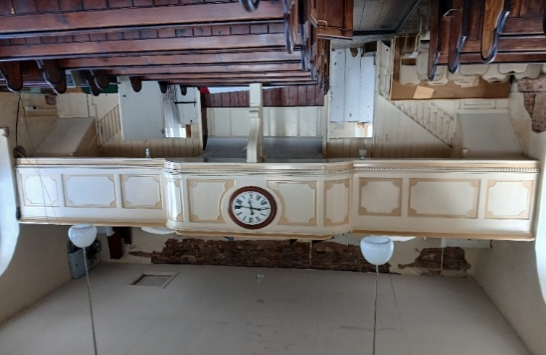
Tucked away just behind Old street and signalled by a magnificent Victorian lantern is one of the oldest Baptist chapels in the country. It dates from 1734 and is now also a lively community hub. You can get into the church with its west gallery and pews via the café.

UPTON ST PETER AND ST PAUL WR8 OJF
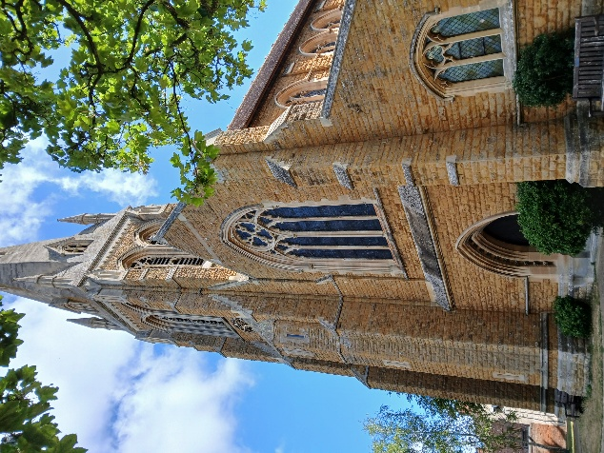
A large light filled Blomfield church from 1877-79 with a striking tall spire in geometrical Decorated style. It has a fine Arts and Crafts west window by Christopher Whall (1905) . Monuments inside range from a limestone effigy of a Boteler knight from the C14 (moved from the earlier church on the site) to a striking modern corona above the nave altar of 8”spirit figures” in forged steel.

GOOD SHEPHERD CHURCH, THE HOOK WR8 0AX
A small 19C Chapel of Ease by G.R Clark in 1870. Beautifully maintained with reredos by the Worcester trained architect Frederick Preedy and a striking Arts and Craft west window.
ST GREGORY, CASTLEMORTON WR13 6BG
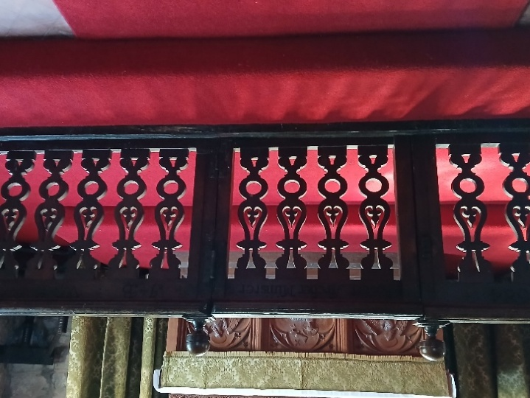
There are remnants of its C12 origin in the chancel north windows and especially the nave doorways, with the north one having a carved Lamb of God figure in the tympanum above the door. The rest of the church is from various medieval periods, including the embattled tower from around 1387. The spire is probably from c 1683 when much else was done to belatedly repair Civil War damage as there has been much fighting around Worcester and along both sides of the Severn.
The communion rails from the late C17 are exceptionally fine. You can also search for no less than 3 fonts in the church! The church was well restored by Ewan Christian in 1878-79.

ALL SAINTS, HOLLYBUSH HR8 1ET
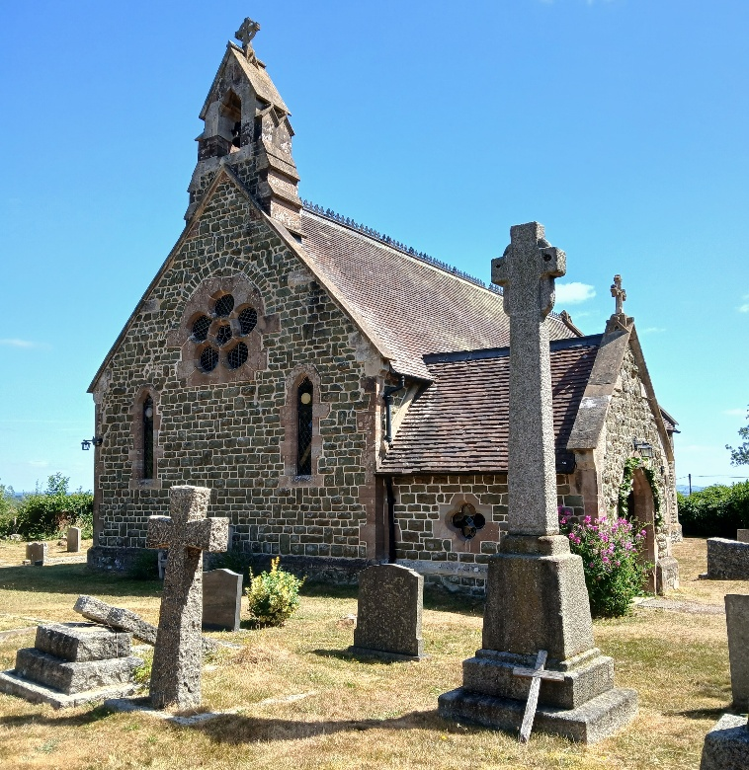

A magnificent site on the slopes of the last Malvern hills with wide views eastwards across the Severn Valley to the Cotswold escarpment and Bredon Hill. The church was designed by Frederick Preedy of Worcester in 1869, as was the fine east window. There are now two colourful modern stained-glass windows in the nave to admire and an immaculately kept church yard to wander in.

BERROW, ST FAITH’S WR13 6AX
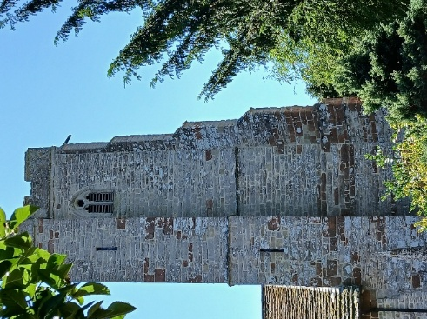
A dellghtful rural church dating back to Norman times (north door) with a striking embattled Perpendicular west tower.
Inside unusually there is no chancel arch, but look for the Norman tub font and the fine C17 carved wooden pulpit.

ELDERSFIELD, ST JOHN THE BAPTIST GL19 4NP
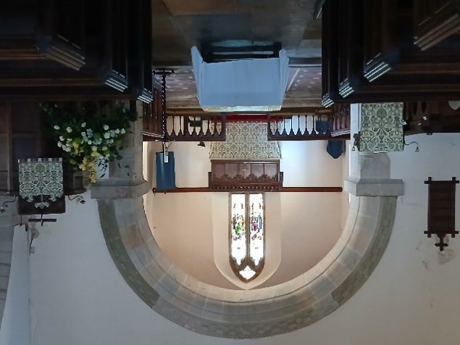
Another Norman origin church as the much altered south doorway shows with the C14 doorway driven through the remains of its Norman predecessor! Simple Norman chancel arch, though the chancel and nave themselves were rebuilt in the C13.
The sturdy three stage tower is mostly C14 topped by a C15 spire and the graveyard contains a good number of C18 chest tombs.

UPPER PENDOCK, OLD CHURCH GL19 4QL
In the care of the Churches Conservation Trust since 1987, it is down a bumpy grass track just north of the M50 (Grid ref 817337) nearly 2 miles east of Pendock itself.
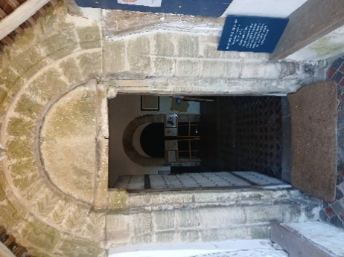
A most interesting church, with significant Norman remains dating from c1170 ( nave, chancel and north doorway). The windows were originally C14 but largely renewed by the Victorians.
It retains its Norman font, Jacobean communion rails and some C16 wooden pews with linenfold panelling. There is a memorial to Sir Joseph Hooker the famous botanist.

BUSHLEY, ST PETERS GL20 6HT
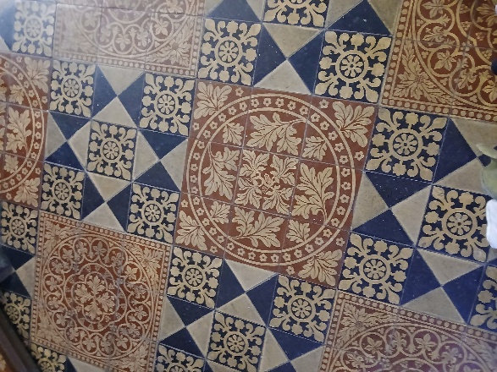
The church was entirely rebuilt by Edward Blore in 1842-43 for the Rev E.C Dowdeswell The chancel was then extended only 15 years later by George Gilbert Scott who also designed many of the fittings.
There are handsome Victorian floor tiles, plus many interesting monuments to earlier Dowdeswells (C16-C18) kept from the previous church on the site.

QUEENHILL,ST NICHOLAS WR8 0RE
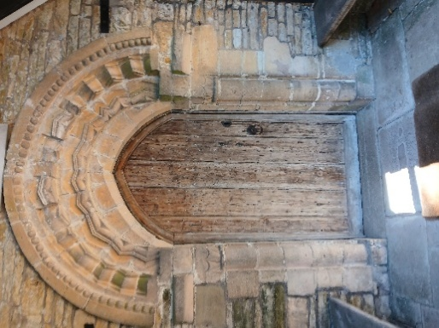
The church is SE of the village and stands just above the M50. Norman nave and south doorway, the former altered in the C14 and the whole building was then subject to two rounds of Victorian restoration. The first was by George Gilbert Scott who added the south porch and the top of the tower.
There is an interesting C15 rood screen and the C17 pulpit has a fine tester. The Victorian glass in the east window was castigated by Pevsner as “ghastly”! See what you think…

N.B. This tour omits St Peter and Paul, Birtsmorton as it is rarely open. Also St Mary , Longdon as unfortunately they have roofing problems. The church is now covered in scaffolding probably for several years and consequently has very limited access.

A good day’s outing and you can finish in Upton with its large choice of cafes, pubs and restaurants.

